POSSIBILITY AND CERTAINTY: may,might,could,must.etc.

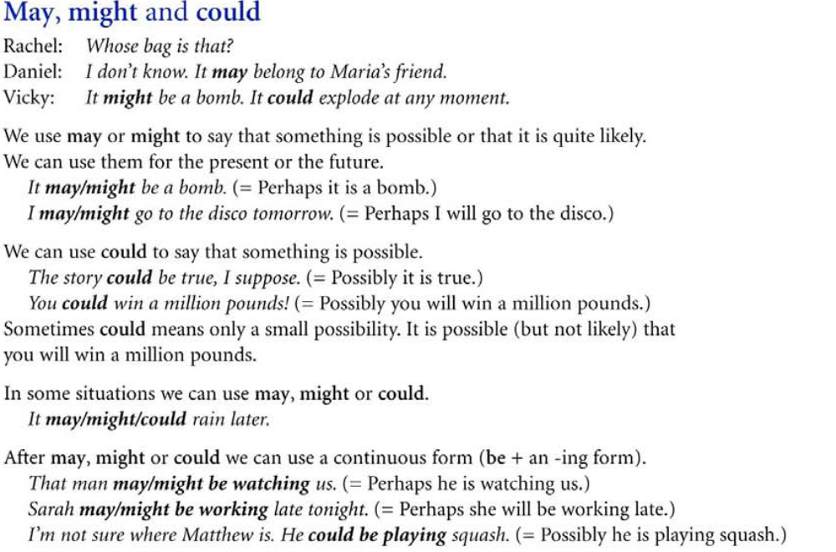
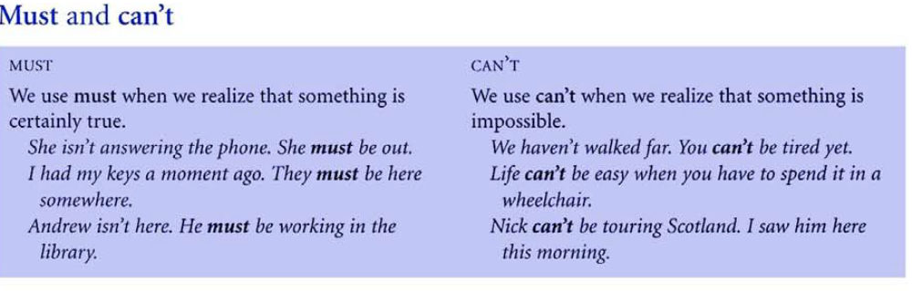
This is Steven’s third day in Australia, so he should be in Melbourne. (I expect him to be in Melbourne, that’s how he planned the trip to be.) | When we expect something will happen, we use should. We also use shouldn’t when we discover that a situation is not as we expected.

MODAL PERFECT
MUST HAVE+V3: to show we are sure about something that happened in the past
He must have been scared when he saw the snake.
CAN’T / COULDN’T HAVE+V3: to show we are certain that something did not happen in the past
Jason can’t / couldn’t have paid the pill-he did not have any money.
COULD HAVE+V3: to show we had the ability to do something in the past but didn’t do it.
I could have bought that laptop but I decided not to.
MAY / MIGHT / COULD HAVE+V3: to show we are guessing about something that happened in the past.
Ann is not here-she may have taken the dog for a walk.
I don’t have my wallet with me; I might have left it at work.
I didn’t receive the invitation. They could have lost my address.

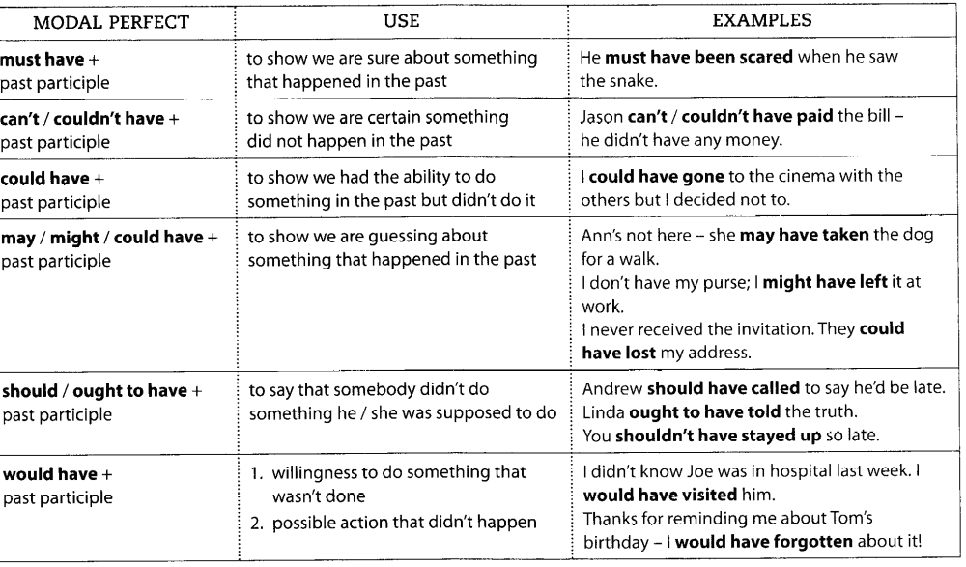

PRACTICE
Choose the correct alternative.
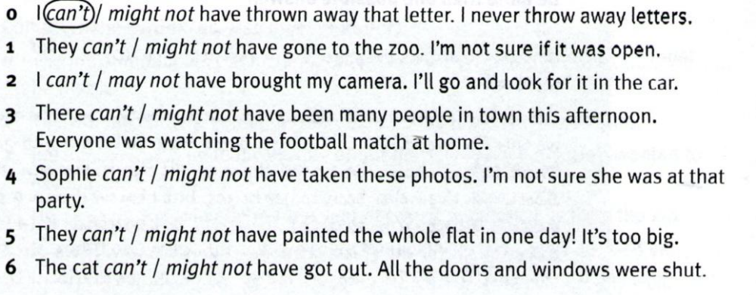

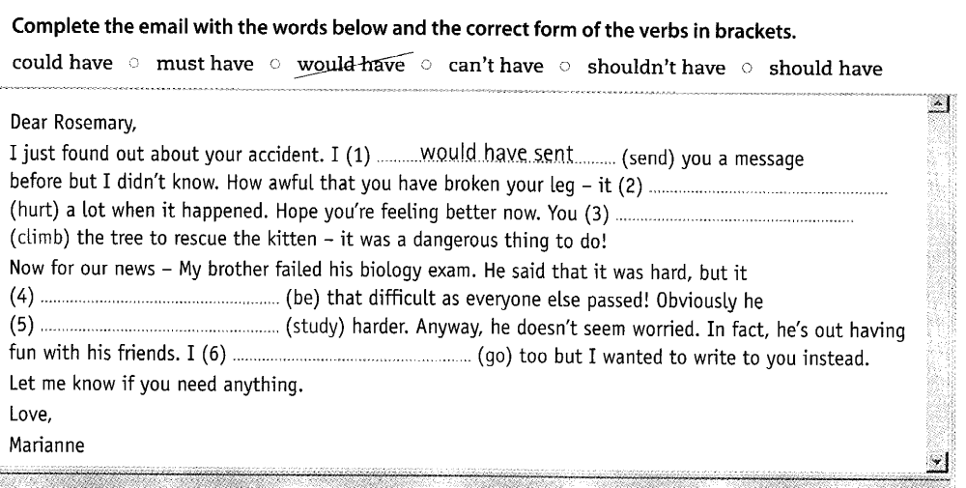

Rewrite the sentences.

1. I regret shouting at the students.
I ________________________________________________at the students.
2. I’m sure he hasn’t gone far because the car is still here.
He_________________________________________ far because the car is still here.
3. She was definitely here earlier because she has left her umbrella.
She________________________________________here earlier because she has left her umbrella.
4. Sam married Angelina, which was a big mistake in my opinion
………………………………………………………………………………………………..
5. What!!! Lisa is feeding a cat! That’s impossible.
………………………………………………………………………………………………..
6. My sister was probably sleeping when you phoned her
………………………………………………………………………………………………..

7. It’s possible to cure this disease with medication.
………………………………………………………………………………………………..
8. She got the file two days ago. It is highly likely that she forgot it. (perfect modal/noun clause)
______________________________________________________________ two days ago.
9. It is highly possible that our words offended her.
What we _________________________________________________

